**PROJECT REPORT**

ON

**“UBIQUITOUS LAB ASSISTANT SYSTEM”**

Submitted in partial fulfilment of the requirements for the partial completion of

**PROJECT FOR COMMUNITY SERVICE [16EC7DCPW1]**

IN

**ELECTRONICS AND COMMUNICATION ENGINEERING**



**VISVESVARAYA TECHNOLOGICAL UNIVERSITY, BELGAUM**

SUBMITTED BY:

**Rahul K P 1BM12EC076**

**Ashwin** **S** **1BM12EC079**

**Damodar**  **1BM12EC119**

Under the Guidance of

<Guide Name>

(Assistant Professor, ECE, BMSCE)

**August - December 2019**



Department of Electronics and Communication Engineering

**B.M.S COLLEGE OF ENGINEERING**

(Autonomous College Affiliated to Visvesvaraya Technological University, Belgaum)

Bull Temple Road, Basavanagudi, Bangalore-560019

**DECLARATION**

We undersigned students of pre-final semester B.E in Electronics and Communication Engineering, BMS College of Engineering, Bangalore, hereby declare that the dissertation entitled “UBIQUITOUS LAB ASSISTANT SYSTEM”, embodies the report of my project work carried out independently by us under the guidance of Mr. Harish V. Mekali, Assistant Professor, E&C Department, BMSCE, Bangalore in partial fulfilment for the award of Bachelor of Engineering in Electronics and Communication from Visvesvaraya Technological University, Belgaum during the academic year 2018-2019.

We also declare that to the best of our knowledge and belief, this project has not been submitted for the award of any other degree on earlier occasion by any student.

Place: Bangalore

Date:

Nemichandra K P 1BM12EC076

Nishanth S 1BM12EC079

Shubham Urkade 1BM12EC119

**B.M.S COLLEGE OF ENGINEERING**

(Autonomous College under VTU)

**Department of Electronics and Communication Engineering**



**CERTIFICATE**

This is to certify that the project entitled **“UBIQUITOUS LAB ASSISTANT SYSTEM”** is a bonafide work carried out by **Nemichandra K P** (USN:1BM12EC076), **Nishanth S** (USN:1BM12EC079) and **Shubham Urkade** (USN:1BM12EC119) in partial fulfillment for the partial completion of PROJECT FOR COMMUNITY SERVICE [16EC7DCPW1] during the academic year 2018-2019.

**Mr. J Dinesh Reddy** **Dr. G. Poornima**  **Dr. B. V. Ravishankar**

Assistant Prof., ECE, BMSCE HOD, ECE, BMSCE Principal, BMSCE

**External Examination:**  **Signature with date:**

1.

2.

**< Dedication >**

**This work is dedicated to all the farmers of the nation**

**ABSTRACT**

Recent advancement in information technology is leading towards a pressurized world altogether by replacing the traditional way of living with technology. With the development of technology and the continuous improvement of people's living standard, people are in pursuit of automated, intelligent and convenient control systems. To make peoples life easier automation systems are required. For example, we find it difficult to get out of bed and switch off the lights at night. It would be very convenient if we could control the lights through our mobile. That’s the main idea of our project. These systems are mainly helpful for older people of our society who are not mobile enough. Many existing, well-established automation systems are based on wired communication.

With the rising power of technology, we are able to accomplish things at a much quicker rate. We have at the touch of a button access to large amounts of information due to the capability of computers and the Internet. Not only has technology given us more information, but it also has given us the ability to communicate, organize, and manage our time. The communication between devices can be used to provide control of various devices to the user.

**ACKNOWLEDGEMENT**

Any achievement, be it scholastic or otherwise does not depend solely on the individual efforts but on the guidance, encouragement and cooperation of intellectuals, elders and friends. A number of personalities, in their own capacities have helped us in carrying out this project work. We would like to take this opportunity to thank them all.

We express profound gratitude to respected principal **Dr. B. V. Ravishankar,** BMS College of Engineering for providing a congenial environment to work in. Our sincere gratitude to **Dr. G. Poornima,** Head of the Department, Electronics and Communication Engineering for encouraging and providing this opportunity to carry out the project in the department.

We would like to thank our guide **Mr. Harish V. Mekali,** Assistant Professor, Department of ECE who helped us in all the ways to carry out the project work. He stood beside and guided us in every step. Our special thanks to **Preethi K. Mane**, Associate Professor, Department of IT who helped us in developing PCB’s for our project.

We will be incomplete, if we don't mention our heartfelt thanks to **Mr. Ravindra**, Former Research Assistant, Robotics Lab, BMSCE, **Halesh Kumar B M**, M.Tech, ECE, BMSCE and **Mithilesh**, M.Tech, ECE, BMSCE who helped us in all the ways to carry out the project work.

We would like to share the joy completing the project to all the team members of NXP lab**.** We thank all our professors for providing the basic knowledge without which this project wouldn't have been possible. Last but not the least we thank our family and friends, who made their valuable support compelled us to maintain a standard throughout our endeavour.

-

Nemichandra K P

Nishanth S

Shubham Urkade

**<SPONSOR DETAILS / CERTIFICATE FROM INDUSTRY>**

We are very much thankful to Visvesvaraya Technological University for funding the entire project.

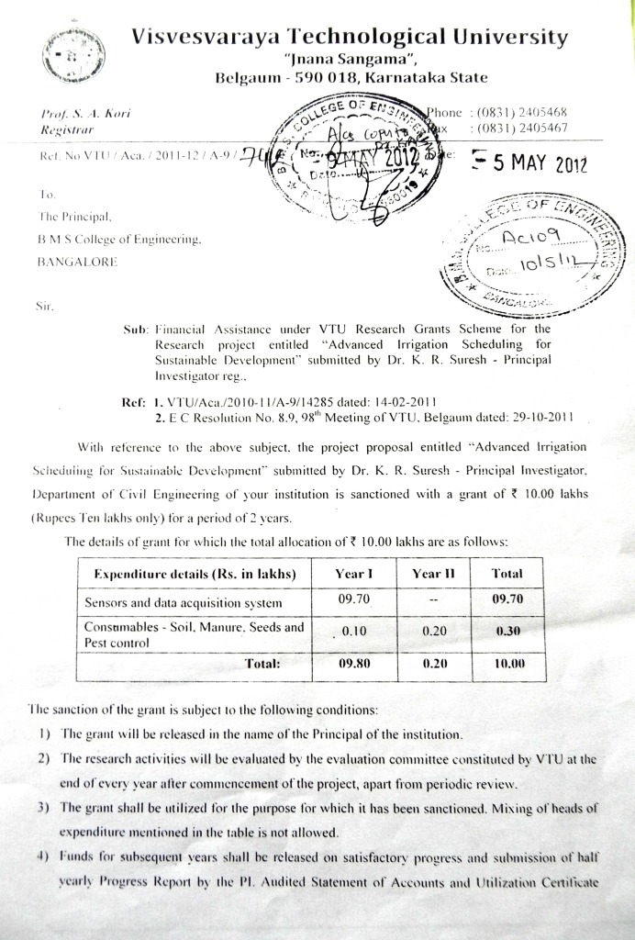

**LIST OF FIGURES**

Figure 1 General RAM Architecture **Error! Bookmark not defined.**

Figure 2 Defect due to opened wire **Error! Bookmark not defined.**

Figure 3 BIST Architecture **Error! Bookmark not defined.**

**……………**

**…………….**

**LIST OF TABLES**

Table 1: Classical and March based algorithms **Error! Bookmark not defined.**

Table 2: Area variations with words size **Error! Bookmark not defined.**

Table 3: Area variations with Bits size **Error! Bookmark not defined.**

**…………….**

**…………….**

**LIST OF ABBREVIATION**

1. AOSP Android Open Source Project
2. ARM Advanced RISC Machines
3. BSP Board Support Package
4. CISC Complex Instruction Set Computer

**…………….**

**…………….**

**Contents**

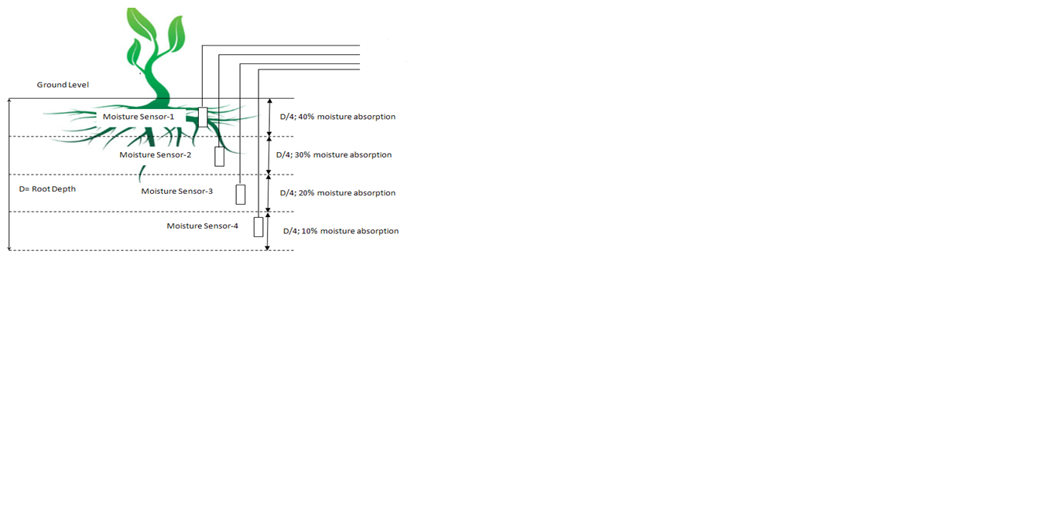

Data acquisition model

SIM900A

Display

Battery

optocoupler

Relay

Soil temperature sensor

Battery level indicator

**TOPIC PAGE NO**

**Chapter 1: Introduction 1**

1.1 Introduction

1.2 Problem definition

1.3 Objective of the project

**Chapter 2: Literature survey 10**

**Chapter 3: Methodology and Implementation 15**

3.1 Block diagram

3.2 Project flow

3.3 Hardware architecture

3.3.1 Circuit diagram

3.3.2 Components description

3.4 Software architecture

3.4.1 Algorithm / Flow chart

**Chapter 4: Results and Discussion**  **30**

**Chapter 5: Conclusion and Future Work 35**

5.1 Conclusion

5.2 Future Work

**REFERENCES 39**

**ANNEXURE**       **40**

**CHAPTER 1: INTRODUCTION**

**1.1 Introduction:**

**BIBLIOGRAPHY**

**Papers**

1. Dr.Fauzia Khurshid & Urusa Ansari, “Effects of Innovative Teaching Strategies on Students’ Performance”, Global Journal of Human Social Science Linguistics & Education, Vol. 12, Issue 10, Version 1.0, 2012
2. Richard M. Felder, Linda K. Silverman, “Learning and Teaching Styles In Engineering Education”, Engr. Education, 78(7), 674–681 (1988)
3. Marita Naudé, “Managing industry-academia partnerships”, DOI:10.3794/ijme.83.300
4. Dr. Damodharan V. S., Mr. Rengarajan.V, “Innovative Methods of Teaching”
5. Shridhar T Doddamani, Arunkumar Giriyapur, “Project based learning in laboratories using open source technologies: case study of a frugal approach”, ICTIEE 2014
6. Julie E. Mills, David F. Treagust, “Engineering education – is problembased Or project-based learning the Answer?” Australasian Journal Of Engineering Education, AAEE – 2003
7. Lopez-Salcedo, Seco-Granados, “Tailoring Project-Based Learning for a communications engineering course”, EAEEIE Annual Conference, pp. 1 – 5, 2009
8. Kumar A, Fernando, S., Panicker, R.C., “Project-Based Learning in Embedded Systems Education Using an FPGA Platform” Education, IEEE Transactions on, vol. 56, Issue. 4 , nov – 2013, pp. 407 – 415
9. Fernandez-Samaca, L., Ramírez, J.M. “An approach to applying Project-Based Learning in engineering courses”, ANDESCON, 2010 IEEE, 15-17 Sept. 2010, pp. 1 - 6

**Books / Reports**

1. ‘Weather Monitoring System’, Project report – 2013 batch

**Webpages**

**Youtube / any other reference**

**ANNEXURE**

**<Awards>**

**<Papers presented certificates>**

**<Paper>**

**<Photos captured during project execution>**

**< DATA sheets >**

**< White papers >**

**Any other information related to the project work**